WHAT IS DEVOPS?
DevOps is a combination of "Development" and "Operations." It is a culture, set of practices, and philosophy that brings software developers (Dev) and IT operations teams (Ops) together to build, test, and deliver software faster and more reliably. It is not just a tool or a technology — it is a mindset and a way of working that encourages collaboration, communication, and continuous improvement across the entire software development and delivery process.
In the past, software teams were divided. Developers focused on writing new features and code, while operations teams focused on keeping systems stable and running. These two groups rarely communicated well, which led to delays, conflicts, and failures. DevOps was created to break down these walls and unite both teams under a shared responsibility for the product.
HISTORY OF DEVOPS
The term DevOps was first introduced around 2008 by Patrick Debois and Andrew Shafer at an Agile conference. In 2009, the first DevOpsDays conference was held in Belgium, which helped spread the concept globally. Since then, DevOps has grown into one of the most important practices in the software industry.
Before DevOps, most companies followed a model called Waterfall, where development happened in long phases — requirement gathering, design, development, testing, and deployment — one after another. This was slow and rigid. Then came Agile, which improved development speed, but the gap between Dev and Ops still remained. DevOps filled that gap by extending Agile principles into operations and deployment.
Today, companies like Google, Amazon, Netflix, and Facebook are known for adopting DevOps practices that allow them to deploy thousands of times per day while keeping their systems highly stable and available.
WHY DEVOPS?
Traditionally, developers wrote code and operations teams deployed and maintained it separately. This caused many problems in real-world software delivery.

Problems without DevOps:
• Slow releases that took weeks or months
• Miscommunication between development and operations teams
• Bugs discovered too late in the process, making them costly to fix
• Manual deployments that were error-prone
• Long recovery times when systems failed
• Blame culture between teams when things went wrong
• Lack of visibility into what the other team was doing
DevOps solves all of these problems by making both teams work together throughout the entire software lifecycle, using automation, shared tools, and a culture of shared responsibility.
KEY PRINCIPLES OF DEVOPS
- Collaboration Dev and Ops teams work together from the very beginning. They share goals, tools, and responsibilities. Instead of throwing code "over the wall" to operations, both teams are involved at every stage.
- Automation Repetitive tasks like testing, building, packaging, and deploying are automated. This reduces human error, saves time, and allows teams to focus on higher-value work. Automation is the backbone of DevOps.
- Continuous Integration (CI) Developers merge their code changes into a shared repository frequently, sometimes multiple times a day. Each merge triggers an automated build and test process. This ensures that problems are detected early and fixed quickly.
- Continuous Delivery (CD) After integration, the code is automatically prepared and tested so that it can be released to production at any time with minimal manual effort. The goal is to always have a deployable version of the software ready.
- Continuous Deployment This goes one step further than Continuous Delivery. Every change that passes automated tests is automatically deployed to production without any manual approval. Companies like Netflix and Amazon use this approach.
- Infrastructure as Code (IaC) Instead of manually setting up servers and environments, infrastructure is defined and managed using code. Tools like Terraform and Ansible allow teams to version, review, and automate infrastructure just like application code.
- Monitoring and Feedback Systems are constantly monitored in production. Logs, metrics, and alerts give teams real-time feedback about application health, performance, and user behavior. This feedback loop is critical for continuous improvement.
- Fail Fast, Fix Fast DevOps encourages identifying and fixing problems as early as possible. The earlier a bug is found, the cheaper and easier it is to fix. Automated tests, code reviews, and monitoring all help catch problems fast.
- Security (DevSecOps) Security is integrated into every phase of the DevOps pipeline rather than being added at the end. This approach is called DevSecOps. Security checks, vulnerability scans, and compliance tests are automated and built into the CI/CD pipeline.
- Continuous Learning and Improvement Teams regularly review what went wrong, what went right, and how processes can be improved. A blameless culture is encouraged, where failures are treated as learning opportunities rather than reasons to punish individuals.
THE DEVOPS LIFECYCLE (8 PHASES)
The DevOps lifecycle is a continuous loop of phases that represent the full journey of software from idea to production and back to improvement. It is often illustrated as an infinity symbol (∞) to show that it never stops.
- PLAN The team defines what needs to be built. Requirements are gathered, user stories are written, and tasks are created and assigned. Tools like Jira, Trello, and Azure Boards are used in this phase.
- CODE Developers write the actual code for the features or fixes. They use version control systems like Git to track changes and collaborate with other developers. Code reviews also happen in this phase.
- BUILD The written code is compiled, packaged, and turned into a deployable artifact. Build tools like Maven, Gradle, or npm are used here. If the build fails, the team is notified immediately.
- TEST Automated tests are run to check that the code works correctly and does not break existing functionality. This includes unit tests, integration tests, and performance tests. Tools like Selenium, JUnit, and Postman are commonly used.
- RELEASE Once testing is complete and the build is approved, the code is prepared for release. This phase involves versioning, changelog creation, and final approvals before pushing to production.
- DEPLOY The code is deployed to the production environment. This can be done manually or fully automatically using CI/CD pipelines. Tools like Jenkins, GitHub Actions, and Spinnaker handle this phase.
- OPERATE The application is now live and being used by real users. The operations team ensures the system is running smoothly, handles scaling, and manages infrastructure. Containers and orchestration tools like Docker and Kubernetes are used here.
- MONITOR The running application is continuously monitored for performance issues, errors, and user behavior. Alerts are set up so the team is notified if something goes wrong. Monitoring tools include Prometheus, Grafana, Datadog, and the ELK Stack (Elasticsearch, Logstash, Kibana).
After monitoring, insights feed back into the Plan phase, and the cycle starts again.
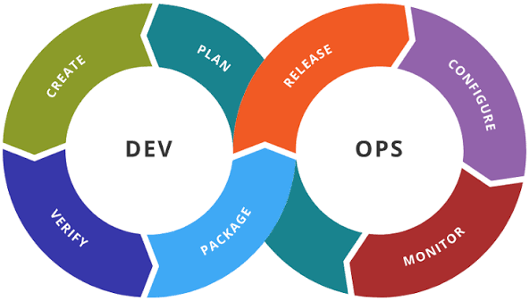

POPULAR DEVOPS TOOLS
- Version Control Git, GitHub, GitLab, Bitbucket Used to track code changes, collaborate with team members, and manage branches and merges.
- CI/CD Tools Jenkins, GitHub Actions, GitLab CI/CD, CircleCI, Travis CI, Azure DevOps Used to automate the build, test, and deployment pipeline.
- Containerization Docker, Podman Used to package applications and their dependencies into containers that run consistently across any environment.
- Container Orchestration Kubernetes (K8s), Docker Swarm, OpenShift Used to manage, scale, and automate the deployment of containers across clusters of machines.
- Configuration Management Ansible, Chef, Puppet, SaltStack Used to automate the setup and configuration of servers and environments.
- Infrastructure as Code Terraform, AWS CloudFormation, Pulumi Used to define and provision infrastructure using code files that can be versioned and reused.
- Monitoring and Logging Prometheus, Grafana, Datadog, ELK Stack, Splunk, New Relic Used to track system health, visualize metrics, and alert teams when problems occur.
- Cloud Platforms Amazon Web Services (AWS), Microsoft Azure, Google Cloud Platform (GCP) Used to host applications, store data, and provide on-demand infrastructure.
- Collaboration Tools Slack, Microsoft Teams, Confluence, Jira Used for team communication, documentation, and project tracking.
BENEFITS OF DEVOPS
- Speed and Faster Delivery DevOps allows teams to release software much faster than traditional approaches. What used to take months can now be done in days or even hours. This means businesses can respond to market changes quickly and get features to users faster.
- Improved Quality Automated testing and continuous integration catch bugs early. Code is tested at every stage of the pipeline, which means fewer defects reach production. Quality becomes a shared responsibility, not just the QA team's job.
- Better Collaboration DevOps removes the wall between development and operations. Teams share tools, goals, and responsibilities. This creates a healthier work environment and reduces the blame culture that often exists in siloed organizations.
- Reliability and Stability With better monitoring, automated rollbacks, and infrastructure as code, systems become more stable. Deployments are less risky because they are automated, repeatable, and tested. Recovery from failures is also faster.
- Scalability DevOps practices make it easier to scale systems up or down based on demand. With cloud platforms and container orchestration tools like Kubernetes, teams can handle traffic spikes without manual intervention.
- Security By integrating security into the pipeline (DevSecOps), vulnerabilities are found and fixed early. Automated security scans run on every code change, making software more secure by default.
- Cost Efficiency Automation reduces manual effort and human error, which lowers operational costs. Cloud infrastructure can be scaled dynamically, meaning you only pay for what you use.
- Customer Satisfaction Faster releases mean users get new features and bug fixes sooner. Better monitoring means problems are detected and fixed before users even notice. All of this leads to a better experience for the end user.
DEVOPS vs TRADITIONAL IT
Aspect Traditional IT DevOps Team Structure Dev and Ops are separate Dev and Ops work together Release Speed Weeks or months Days, hours, or minutes Deployment Manual and infrequent Automated and frequent Testing Done at end of cycle Done continuously Feedback Slow, after release Fast, real-time monitoring Risk High (big releases) Low (small, frequent releases) Culture Blame when things fail Learn from failures together Infrastructure Manual setup Infrastructure as Code Collaboration Low High
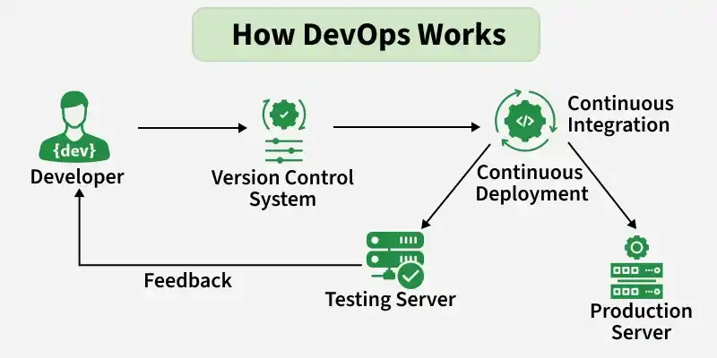

DEVOPS ROLES AND CAREERS
- DevOps Engineer A DevOps Engineer is responsible for building and maintaining the CI/CD pipeline, managing cloud infrastructure, automating deployments, and ensuring system reliability. They need to understand both development and operations.
- Site Reliability Engineer (SRE) SRE is a role created by Google. SREs apply software engineering principles to operations problems. They focus on system reliability, availability, and performance using automation.
- Cloud Engineer Focuses on designing and managing cloud infrastructure on platforms like AWS, Azure, or GCP. Often works closely with DevOps teams.
- Security Engineer (DevSecOps) Integrates security practices into the DevOps pipeline. Runs automated security scans, manages access controls, and ensures compliance.
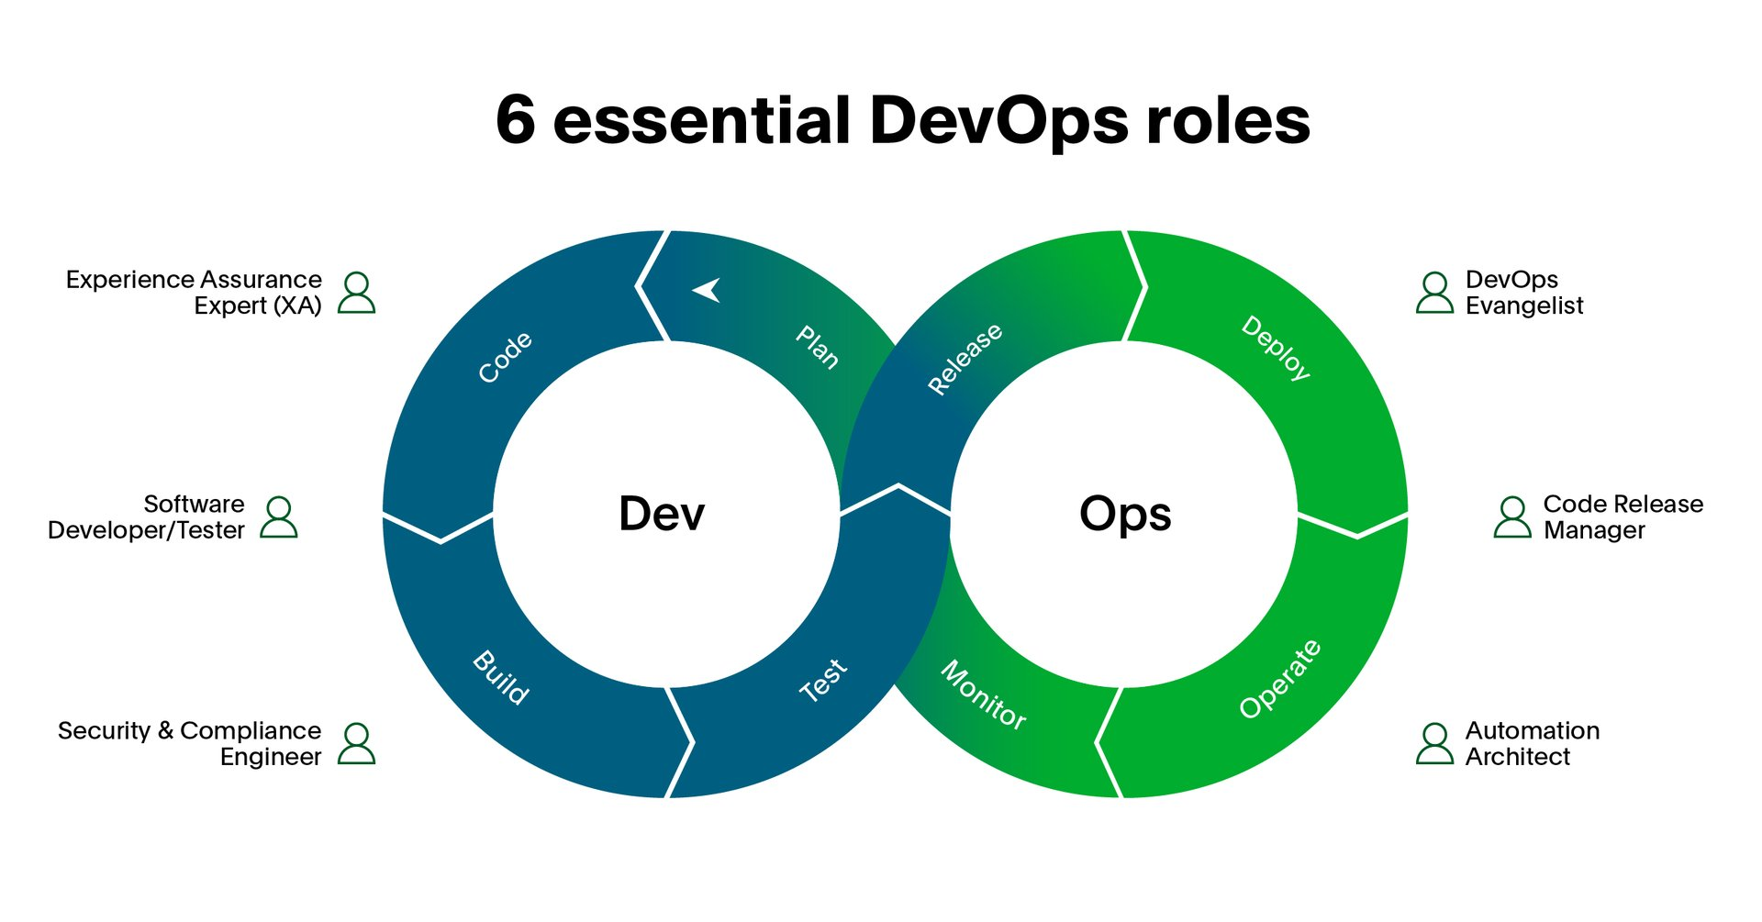
Skills needed for a DevOps career:
• Linux and command-line skills
• Scripting (Bash, Python)
• Git and version control
• CI/CD tools (Jenkins, GitHub Actions)
• Docker and Kubernetes
• Cloud platforms (AWS, Azure, GCP)
• Monitoring tools (Prometheus, Grafana)
• Infrastructure as Code (Terraform, Ansible)
• Strong communication and collaboration skills

CONCLUSION
DevOps is not just a set of tools — it is a cultural transformation that changes how teams think, collaborate, and deliver software. By breaking down silos, embracing automation, and focusing on continuous improvement, organizations can deliver better software faster and with greater confidence. Whether you are a developer, a system administrator, a tester, or a manager, understanding DevOps is essential in today's fast-moving technology world. Companies that adopt DevOps practices consistently outperform those that do not, in terms of speed, quality, stability, and customer satisfaction. DevOps is the present and the future of software delivery.

ADVANTAGES OF DEVOPS
1. Faster Software Delivery
No more waiting months for a release. DevOps makes shipping code quick, smooth, and continuous.
- Teams release updates in hours or days instead of weeks
- Automated pipelines push code from development to production rapidly
- Customers get new features and bug fixes without long waits
- Businesses stay ahead of competitors by moving fast
2. Better Collaboration Between Teams
Dev and Ops used to fight like cats and dogs. DevOps fixes that.
- Developers and operations work as one unified team
- Shared goals mean no more blame games when things break
- Everyone owns the product together from start to finish
- Communication becomes open, honest, and continuous

3. Higher Quality Software
More automation means fewer humans making silly mistakes at 2am.
- Automated testing catches bugs before they reach production
- Code is tested at every single stage of the pipeline
- Small frequent releases are easier to test and debug
- Fewer critical failures in live production environments
4. Faster Recovery From Failures
Things will break. DevOps just makes sure you fix it before anyone notices.
- Real-time monitoring detects issues the moment they happen
- Automated rollbacks restore the last working version instantly
- Teams know exactly where the problem is thanks to detailed logs
- Mean Time To Recovery (MTTR) is drastically reduced
5. Continuous Feedback Loop
You always know what's happening with your app. No guessing, no surprises.
- Monitoring tools give real-time data on performance and errors
- User behavior is tracked so teams know what to improve
- Feedback from production feeds directly back into planning
- Teams make smarter decisions based on actual data
6. Automation Everywhere
Why do manually what a machine can do better and faster?
- Builds, tests, and deployments are fully automated
- Repetitive tasks are eliminated saving hours of manual work
- Human errors in deployment and configuration are reduced massively
- Teams focus on creative and high value work instead of boring repetitive tasks
7. Improved Security (DevSecOps)
Security is baked in from day one, not slapped on at the end.
- Automated security scans run on every single code change
- Vulnerabilities are caught early when they are cheap to fix
- Compliance checks are automated and consistent
- Risk of a serious security breach is significantly reduced
8. Scalability Made Easy
Handle a million users or ten. DevOps handles the scaling for you.
- Cloud infrastructure scales automatically based on demand
- Kubernetes manages containers across hundreds of machines effortlessly
- No manual intervention needed during traffic spikes
- Infrastructure as Code makes spinning up new environments super fast
9. Cost Efficiency
Do more with less. Automation saves money, time, and headaches.
- Fewer manual processes means lower operational costs
- Bugs caught early are far cheaper to fix than production bugs
- Cloud resources scale down automatically when not needed
- Less downtime means less revenue lost
10. Happier Teams and Happier Customers
At the end of the day it is about people. DevOps wins on both sides.
- Developers spend less time firefighting and more time building cool things
- Operations teams are not stressed about risky manual deployments
- Customers get faster updates, fewer bugs, and a smoother experience
- A blameless culture makes the workplace actually enjoyable to work in
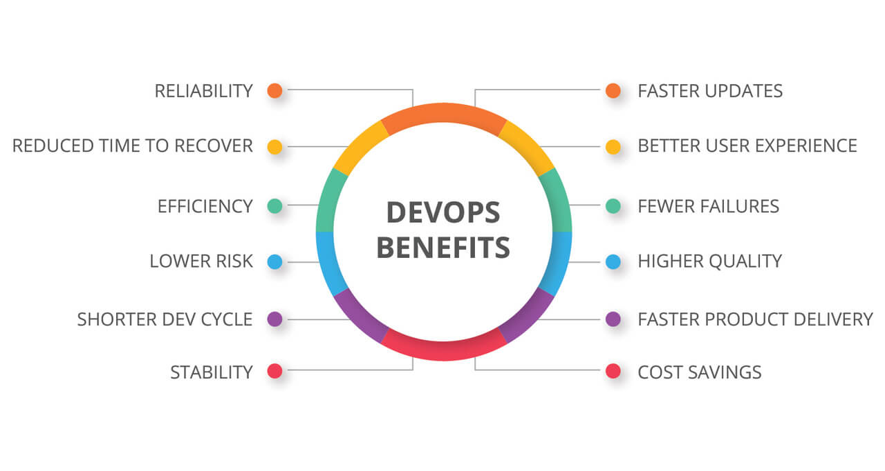
WHAT IS AGILE METHODOLOGY
Agile is a way of developing software that focuses on delivering work in small, fast chunks rather than one big release at the end. Think of it as building a car by first giving the customer a skateboard, then a bicycle, then a motorbike, and finally the car — instead of making them wait 2 years for the full thing.
Agile was officially born in 2001 when 17 software developers came together and wrote the Agile Manifesto — a simple document with 4 values and 12 principles that changed the software world forever.
THE 4 CORE VALUES OF AGILE
- Individuals and interactions over processes and tools
- Working software over comprehensive documentation
- Customer collaboration over contract negotiation
- Responding to change over following a fixed plan
Basically — people matter more than paperwork, and being flexible beats being rigid.
12 PRINCIPLES OF AGILE
- Deliver working software frequently — weeks not months
- Welcome changing requirements even late in development
- Business people and developers must work together daily
- Build projects around motivated individuals and trust them
- Face to face conversation is the best form of communication
- Working software is the primary measure of progress
- Maintain a sustainable and consistent pace of work
- Continuous attention to technical excellence and good design
- Simplicity — do not build what you do not need
- Self organizing teams produce the best results
- Regularly reflect and adjust to become more effective
- Satisfy the customer through early and continuous delivery
HOW AGILE WORKS
Instead of planning everything upfront and delivering at the very end, Agile breaks work into short cycles called iterations or sprints (usually 1 to 4 weeks). At the end of each cycle, a working piece of software is delivered and reviewed.
- Requirements can change anytime and the team adapts
- Customer feedback is collected after every iteration
- The team continuously improves how they work
- Problems are caught early instead of at the very end
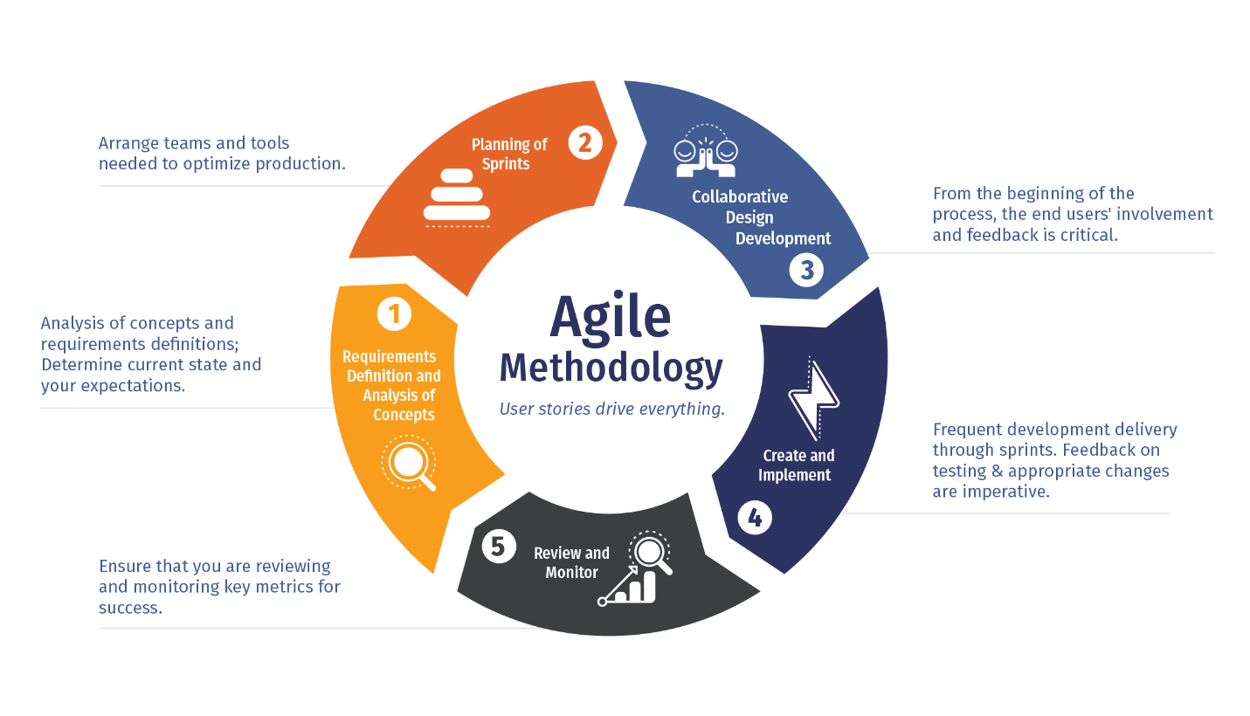
AGILE vs TRADITIONAL (WATERFALL)
Waterfall — Plan everything → Design → Build → Test → Release. One big release after months or years. If something is wrong, you find out way too late.
Agile — Plan a little → Build a little → Test a little → Get feedback → Repeat. Problems are found fast and fixed fast.
- Waterfall is rigid, Agile is flexible
- Waterfall delivers once, Agile delivers continuously
- Waterfall hates change, Agile welcomes change
- Waterfall is slow, Agile is fast
POPULAR AGILE FRAMEWORKS
- Scrum — Most popular, uses sprints and defined roles
- Kanban — Visual board based flow system, no fixed sprints
- SAFe — Scaled Agile for large enterprises
- XP (Extreme Programming) — Focuses heavily on technical practices
- Lean — Eliminate waste and deliver value fast
WHAT IS SCRUM
Scrum is the most widely used Agile framework. It gives teams a clear structure — defined roles, events, and rules — to deliver working software in short cycles called sprints. If Agile is the philosophy, Scrum is the playbook.
The name comes from rugby — in rugby, a scrum is when the whole team huddles together and works as one unit to move forward. Same idea here.
3 CORE ROLES IN SCRUM
Product Owner
- Represents the customer and business
- Owns and manages the Product Backlog (the to-do list of everything)
- Decides what gets built and in what order
- Makes sure the team is always working on the most valuable things
Scrum Master
- The team's coach and protector
- Removes blockers and obstacles that slow the team down
- Makes sure Scrum rules and practices are followed
- Shields the team from outside distractions
- Does NOT manage the team — facilitates instead
Development Team
- The people actually building the product
- Usually 3 to 9 people — small enough to move fast
- Cross functional — designers, developers, testers all in one team
- Self organizing — they decide how to do the work themselves

5 KEY SCRUM EVENTS
1. Sprint
- The heart of Scrum — a fixed time box of 1 to 4 weeks
- The team picks work from the backlog and commits to completing it
- No scope changes allowed once the sprint starts
- At the end a working product increment is delivered
2. Sprint Planning
- Happens at the start of every sprint
- Team decides what they will work on during the sprint
- Work is broken into tasks and estimated
- The team creates the Sprint Backlog from the Product Backlog
3. Daily Scrum (Daily Standup)
- A short 15 minute meeting every single day
- Each team member answers 3 questions:
→ What did I do yesterday?
→ What will I do today?
→ Is anything blocking me?
- Keeps everyone aligned and problems visible fast
4. Sprint Review
- Happens at the end of the sprint
- Team demonstrates what was built to stakeholders and customers
- Feedback is collected and the backlog is updated
- Real working software is shown — not slides or documents
5. Sprint Retrospective
- Also at the end of the sprint — after the review
- Team reflects on how they worked, not what they built
- Three questions are asked:
→ What went well?
→ What did not go well?
→ What can we improve next sprint?
- Continuous improvement in action
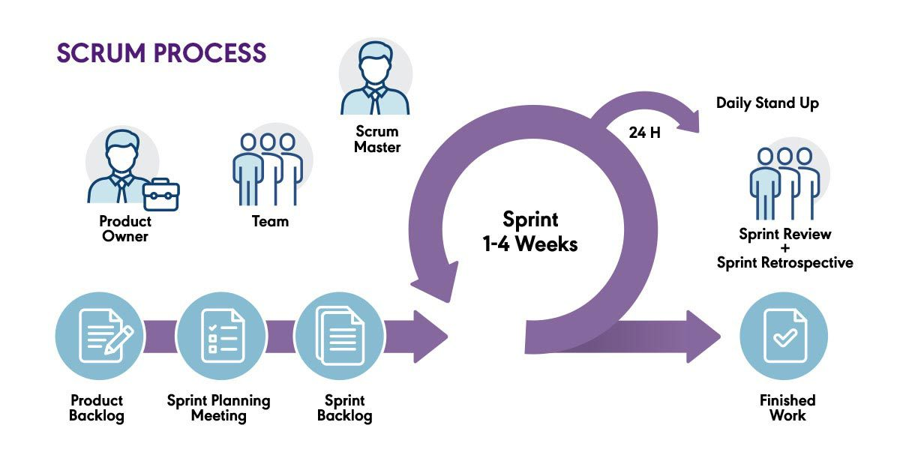
3 KEY SCRUM ARTIFACTS
Product Backlog
- The master list of everything that needs to be built
- Owned and prioritized by the Product Owner
- Constantly updated as requirements change
- Items at the top are most important and most detailed
Sprint Backlog
- The list of tasks the team commits to completing in the current sprint
- Created during Sprint Planning
- Owned by the Development Team
- Updated daily as work progresses
Product Increment
- The working, usable piece of software delivered at the end of each sprint
- Must meet the team's Definition of Done
- It is potentially shippable — meaning it could go to production right now
SCRUM IN REAL LIFE — HOW A SPRINT LOOKS
Day 1 — Sprint Planning. Team picks work and plans the sprint.
Days 2 to 13 — Team builds, tests, and integrates every single day. Daily standups keep everyone in sync.
Day 14 — Sprint Review. Team shows working software to stakeholders and gets feedback.
Day 14 — Sprint Retrospective. Team talks about what to improve next sprint.
Day 15 — New sprint begins. Repeat.
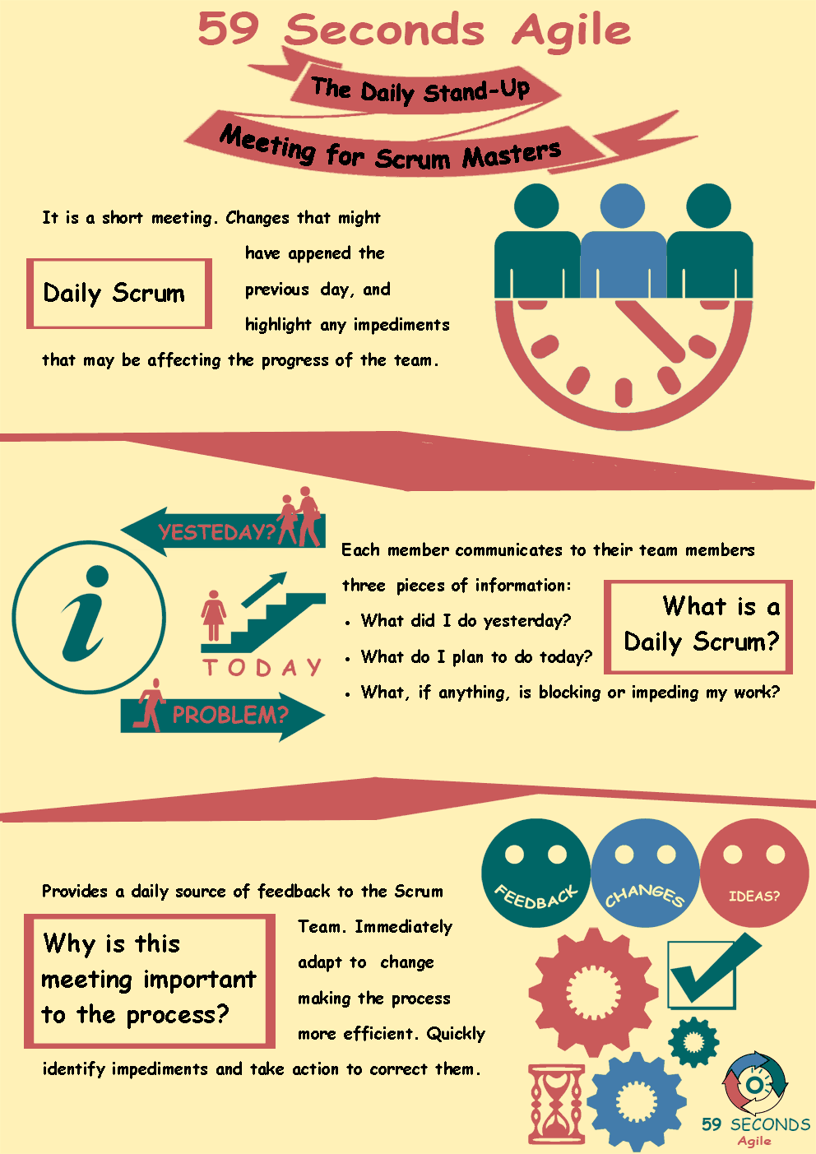

BENEFITS OF SCRUM
- Delivers working software every 1 to 4 weeks
- Problems and blockers are surfaced immediately in daily standups
- Customer gets to see progress and give feedback regularly
- Team continuously improves how they work
- Scope creep is controlled — changes go into the backlog first
- Transparency is built into every event and artifact
- Teams become more productive and self sufficient over time
AGILE vs SCRUM — WHAT IS THE DIFFERENCE
- Agile is the mindset and philosophy
- Scrum is a specific framework that implements Agile
- Agile does not tell you exactly how to work — Scrum does
- You can be Agile without using Scrum
- But if you use Scrum, you are definitely being Agile
- Think of Agile as the religion and Scrum as one of the practices within it
CONCLUSION
Agile changed the way the world builds software — from slow, rigid, and risky to fast, flexible, and customer focused. Scrum gave teams a practical, structured way to actually live those Agile values every single day. If you work in tech, product, or even project management — understanding Agile and Scrum is not optional anymore. It is the industry standard and knowing it well will make you a far more effective team player and professional.

IMPORTANT MEETINGS IN AGILE
In Agile, meetings are called Ceremonies or Events. These are not boring sit-and-listen meetings — they are focused, time-boxed, and every single one has a clear purpose. No unnecessary meetings, no wasted time.
1. SPRINT PLANNING
The meeting that kicks off every sprint. The whole team sits together and decides what they are going to build in the next 1 to 4 weeks.
Who attends:
- Product Owner
- Scrum Master
- Development Team
What happens:
- Product Owner presents the top priority items from the Product Backlog
- Team discusses each item and asks questions
- Team estimates the effort needed for each task
- Team commits to what they can realistically finish in the sprint
- Sprint Backlog is created
Duration: Usually 2 to 4 hours for a 2 week sprint
Key outcome: A clear Sprint Goal and a Sprint Backlog the team is committed to
2. DAILY SCRUM (DAILY STANDUP)
The most frequent meeting in Agile. Happens every single day at the same time and same place. Short, sharp, and to the point.
Who attends:
- Development Team (mandatory)
- Scrum Master (facilitates)
- Product Owner (optional)
What happens — 3 simple questions:
- What did I complete yesterday?
- What will I work on today?
- Is there anything blocking my progress?
Duration: Strictly 15 minutes. Not a second more.
Key outcome: Everyone is aligned, blockers are visible, and the team stays on track
Important rules:
- Stand up during the meeting so it stays short
- It is NOT a status report to the manager
- Detailed problem solving happens AFTER the standup with only relevant people
- Same time every day builds a healthy habit
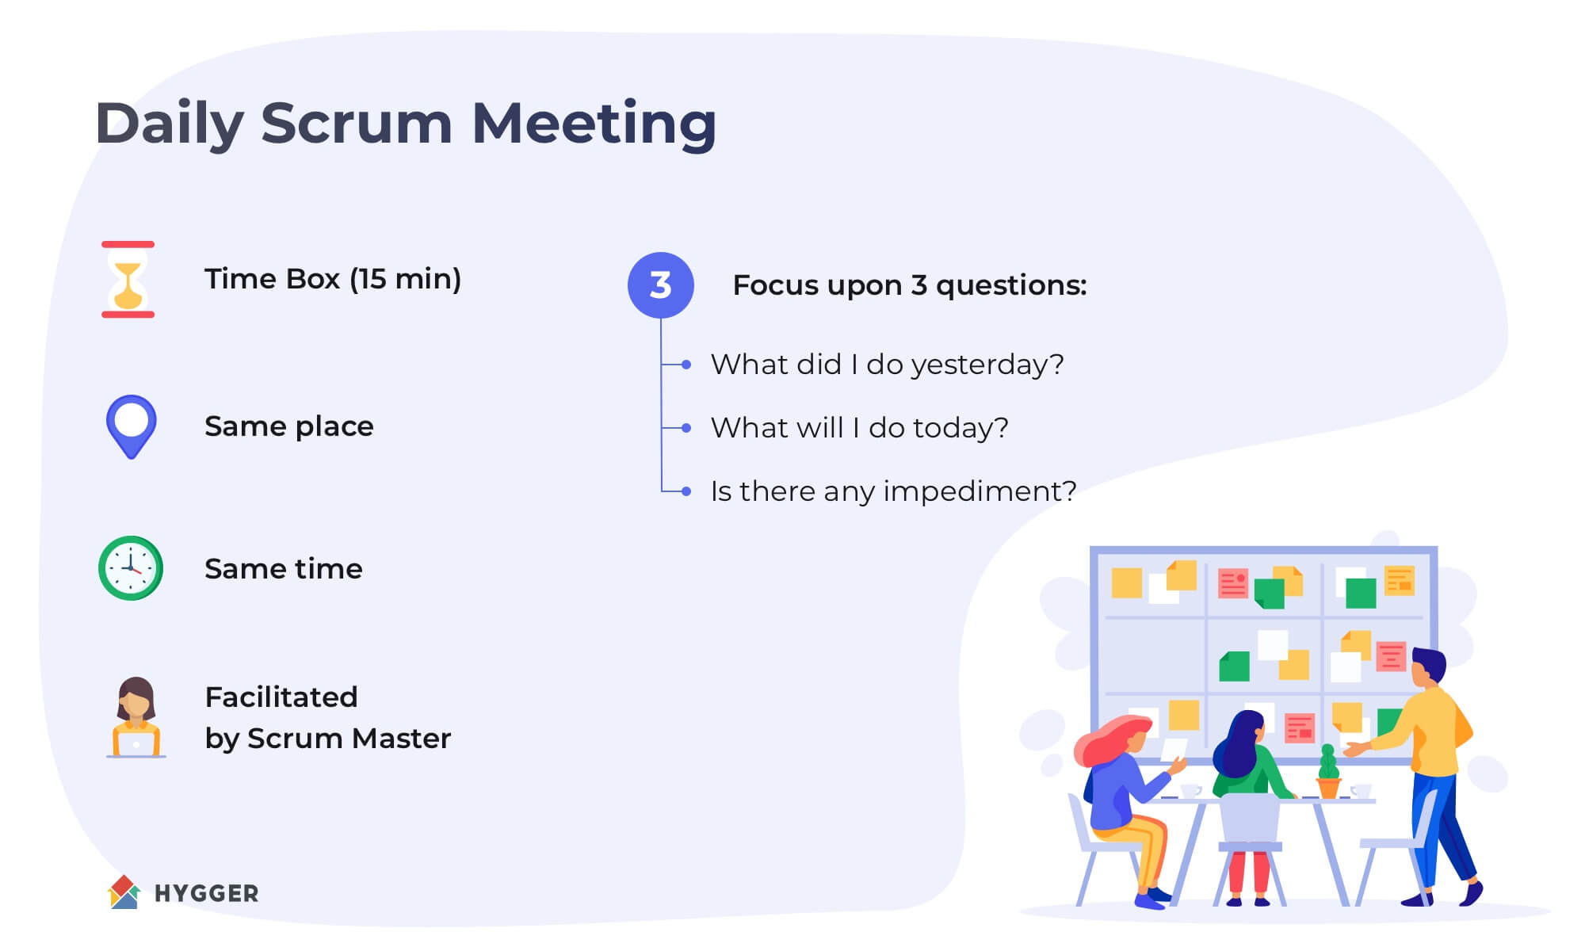
3. SPRINT REVIEW
Happens at the end of every sprint. The team shows the world what they built. Real working software — not PowerPoint slides.
Who attends:
- Product Owner
- Scrum Master
- Development Team
- Stakeholders and customers (very important)
What happens:
- Team demonstrates the completed features live
- Stakeholders give feedback on what they see
- Product Owner discusses what is done and what is not
- Product Backlog is updated based on feedback
- Next priorities are discussed
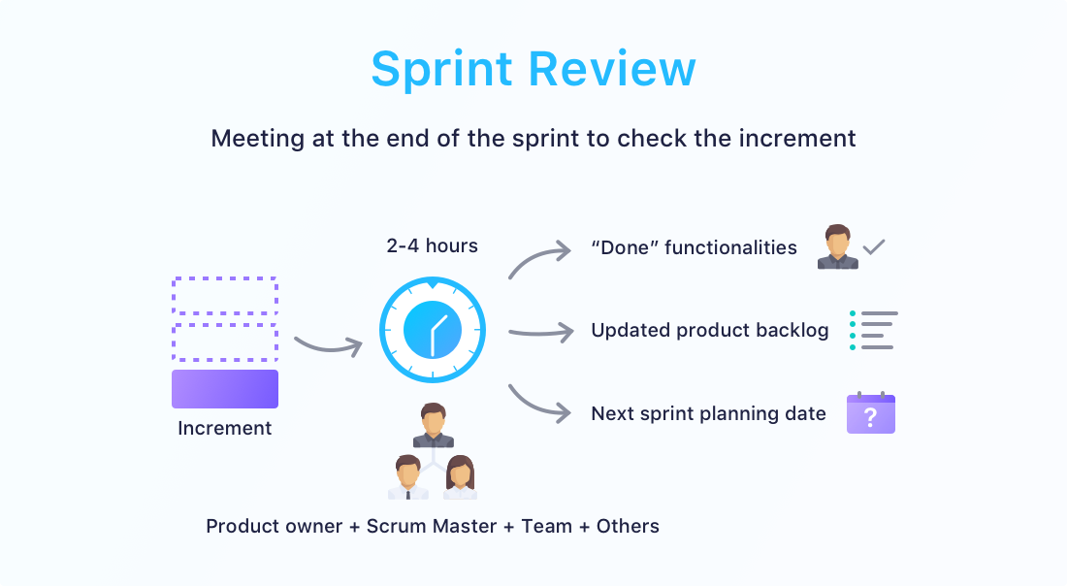

Duration: Around 1 to 2 hours for a 2 week sprint
Key outcome: Working software is shown, feedback is collected, backlog is refined
Why it matters:
- Customers see real progress not just status updates
- Feedback is collected while there is still time to change things
- Builds trust between the team and stakeholders
4. SPRINT RETROSPECTIVE
The most honest meeting in Agile. The team looks inward and talks about how they worked — not what they built. This is where real improvement happens.
Who attends:
- Scrum Master (facilitates)
- Development Team
- Product Owner (optional but encouraged)
What happens — 3 powerful questions:
- What went well this sprint?
- What did not go well?
- What will we do differently next sprint?
Duration: Around 1 to 1.5 hours for a 2 week sprint
Key outcome: A list of specific improvement actions for the next sprint
Why it matters:
- Teams that skip retros stop growing
- Creates a safe space to speak honestly without blame
- Small improvements every sprint add up to massive gains over time
- The team owns their own process and fixes it themselves
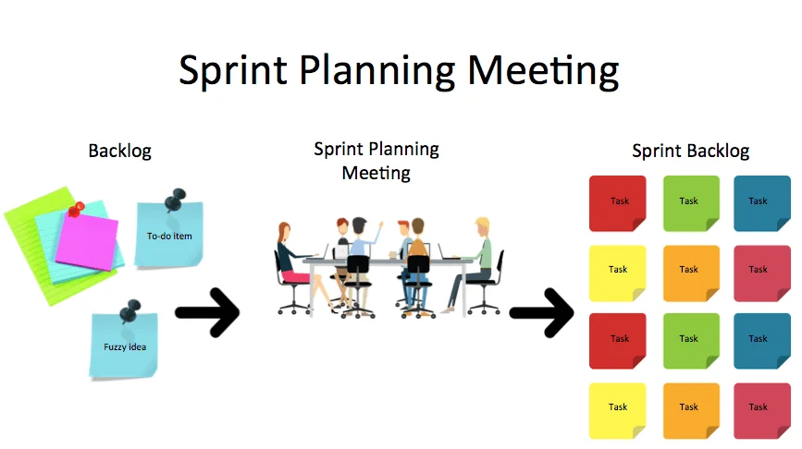
5. BACKLOG REFINEMENT (GROOMING)
A mid sprint meeting where the team prepares future work so Sprint Planning is smooth and fast. Think of it as doing your homework before the exam.
Who attends:
- Product Owner
- Development Team
- Scrum Master (optional)
What happens:
- Product Owner presents upcoming backlog items
- Team asks questions and clarifies requirements
- Items are broken down into smaller manageable tasks
- Effort is estimated for each item
- Items are prioritized and reordered if needed
Duration: Around 1 hour per week
Key outcome: A well prepared and prioritized backlog ready for the next sprint
Why it matters:
- Prevents confusion and wasted time during Sprint Planning
- Ensures the team understands requirements before committing
- Keeps the backlog clean, relevant, and up to date
6. RELEASE PLANNING MEETING
A bigger picture meeting that looks beyond a single sprint. The team and business plan which features will be released and when over the next few months.
Who attends:
- Product Owner
- Development Team
- Scrum Master
- Business stakeholders and managers
What happens:
- High level roadmap is discussed
- Release dates and milestones are planned
- Dependencies between teams are identified
- Risks are discussed and flagged early
- Business goals are aligned with development capacity
Duration: Half a day to a full day depending on scope
Key outcome: A release roadmap that aligns business expectations with team capacity
7. SCRUM OF SCRUMS
When multiple Scrum teams are working on the same product, they need to coordinate. This is where Scrum of Scrums comes in.

Who attends:
- One representative from each Scrum team (usually a senior developer or team lead)
- Scrum Master of each team
What happens:
- Each team representative gives a quick update
- Cross team dependencies are discussed
- Blockers that affect multiple teams are surfaced
- Conflicts and overlaps in work are resolved
Duration: Around 30 to 45 minutes
Key outcome: Multiple teams stay coordinated and do not step on each other's work
QUICK SUMMARY TABLE
Sprint Planning
→ When: Start of every sprint
→ Duration: 2 to 4 hours
→ Purpose: Decide what to build this sprint
Daily Standup
→ When: Every single day
→ Duration: 15 minutes
→ Purpose: Stay aligned and surface blockers
Sprint Review
→ When: End of every sprint
→ Duration: 1 to 2 hours
→ Purpose: Demo working software to stakeholders
Sprint Retrospective
→ When: End of every sprint (after review)
→ Duration: 1 to 1.5 hours
→ Purpose: Improve how the team works
Backlog Refinement
→ When: Mid sprint, once or twice a week
→ Duration: 1 hour
→ Purpose: Prepare and clarify future work
Release Planning
→ When: Before a major release or quarterly
→ Duration: Half to full day
→ Purpose: Plan what gets released and when
Scrum of Scrums
→ When: Multiple times a week
→ Duration: 30 to 45 minutes
→ Purpose: Coordinate between multiple teams
GOLDEN RULES FOR AGILE MEETINGS
- Every meeting must have a clear purpose — no pointless gatherings
- All meetings are time boxed — start on time, end on time
- The right people must be in the room — no unnecessary attendees
- Outcomes and action items must be captured after every meeting
- Retrospectives must be a safe and blameless space
- Daily standups are for the team — not for managers to get status updates
- Skip ceremonies consistently and your Agile process will fall apart fast

ADVANTAGES OF AGILE
Agile is not just a methodology — it is a smarter, faster, and more human way of building software. Here is why teams all over the world swear by it.
1. Faster Delivery of Working Software
No more waiting 6 months to see something live. Agile ships fast.
- Working software is delivered at the end of every sprint (every 1 to 4 weeks)
- Customers get real features in their hands quickly
- Businesses can launch early and improve later
- Value reaches the customer continuously instead of all at once at the end
2. Welcomes Change at Any Point
Requirements change. Markets change. Customers change their minds. Agile is totally okay with that.
- Changes can be introduced even late in the development process
- New priorities are picked up in the next sprint without derailing everything
- Teams adapt instead of resist when business needs shift
- Competitors cannot catch you off guard because you can pivot fast
3. Customer is Always in the Loop
In Agile the customer is not a stranger who shows up at the end. They are part of the journey.
- Regular sprint reviews mean customers see progress every few weeks
- Feedback is collected continuously and acted on immediately
- Product is built based on what the customer actually wants not what someone assumed
- Misunderstandings are caught early before they become expensive mistakes
4. Better Quality Product
Agile bakes quality into every single sprint instead of testing everything at the very end.
- Testing happens continuously throughout development not just at the end
- Bugs are found and fixed early when they are cheap and easy to fix
- Code is reviewed regularly keeping technical debt low
- Definition of Done ensures every feature meets quality standards before moving on
5. Increased Team Collaboration
Agile turns a group of individuals into one powerful united team.
- Daily standups keep everyone aligned and aware of what others are doing
- Cross functional teams work together — developers, testers, designers all in one team
- Shared ownership means everyone cares about the final product
- Transparency builds trust within the team and with stakeholders
6. Early Detection of Problems
Problems do not hide in Agile. They surface fast and get fixed fast.
- Daily standups surface blockers every single day
- Short sprints mean issues are discovered within weeks not months
- Retrospectives help the team identify process problems and fix them
- Risk is spread across many small deliveries instead of one big risky release
7. Higher Customer Satisfaction
Happy customers are the whole point. Agile consistently delivers that.
- Customers see their feedback actually being implemented in real time
- Product evolves based on real user needs not guesswork
- Frequent releases mean customers always have access to the latest improvements
- Transparency in progress builds confidence and trust with clients
8. Reduced Risk
Big bang releases are scary and risky. Agile makes risk manageable.
- Small frequent releases mean if something goes wrong the damage is minimal
- Course corrections happen early before too much time and money is wasted
- Teams validate ideas with real users before building the full thing
- No nasty surprises at the end of a 12 month project
9. Continuous Improvement
Agile teams never stop getting better. Every sprint is a chance to level up.
- Sprint retrospectives force the team to reflect and improve after every sprint
- Processes, tools, and communication are constantly refined
- Team velocity improves over time as the team learns what works
- A culture of improvement becomes second nature to the team
10. Better Visibility and Transparency
Everyone always knows what is happening. No hidden surprises.
- Product backlog is visible to everyone — team, stakeholders, and customers
- Burndown charts show exactly how much work is left at any point
- Sprint goals make priorities crystal clear for the entire team
- Stakeholders are never left wondering what the team is working on
11. Motivated and Empowered Teams
Agile treats developers like professionals not just code machines.
- Teams are self organizing — they decide how to do their own work
- People have ownership and accountability over what they build
- Collaboration and respect are built into the culture
- Less micromanagement means more creativity and better output
12. Faster Return on Investment (ROI)
Businesses start getting value from day one not after a year of waiting.
- Working features are released early so the product generates value sooner
- Budgets are used more efficiently because waste is eliminated continuously
- Costly mistakes are avoided by validating with real users early
- Stakeholders see results quickly which builds confidence to continue investing
13. Scales Well for Any Team Size
Agile works for a 3 person startup and a 3000 person enterprise.
- Small teams use basic Scrum or Kanban and move lightning fast
- Large organizations use SAFe or LeSS to scale Agile across many teams
- Remote and distributed teams adopt Agile easily with digital tools
- The framework adapts to the team not the other way around
14. Encourages Innovation
When teams feel safe and empowered they think creatively and build better things.
- Retrospectives encourage teams to experiment with new approaches
- Failing fast in a small sprint is safe and cheap — learning is celebrated
- Cross functional collaboration sparks ideas that siloed teams never discover
- Customers co-create the product which leads to genuinely innovative solutions
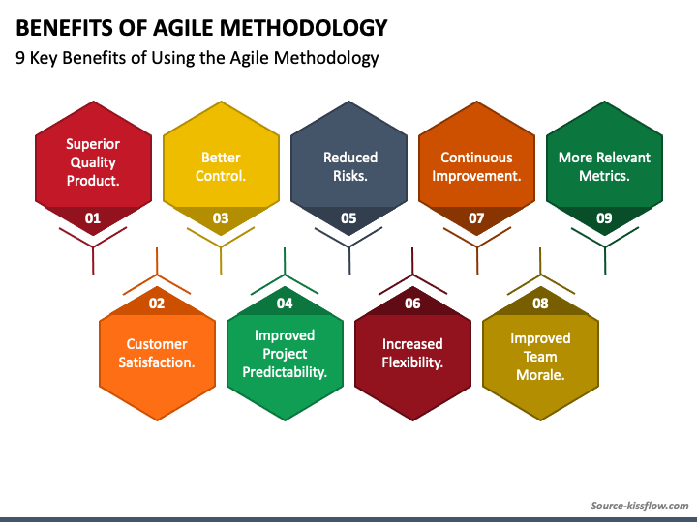

QUICK SUMMARY
- Faster delivery — ship working software every few weeks
- Flexible — welcome change anytime without panic
- Customer focused — build what users actually want
- Better quality — test continuously not just at the end
- Less risk — small releases mean small failures
- Motivated teams — self organizing and empowered
- Continuous improvement — get better every single sprint
- Higher ROI — value delivered early and often
